### Industrial Project

On

### “GRN Data Receipts Quantity Analysis” of Escorts Kubota Ltd.

Submitted in the fulfillment of the

Requirements for the award of the degree Of

**MASTER OF Business Administration**



By

#### Raj Kumar 22L9MBA34106

Under the Externa Supervision of

Manoj Chauhan (PPC L5 Manager)& Internal Supervision of

Dr. Dalip Raina

Skill Asst. Professor

**SKILL DEPARTMENT OF MANAGEMENT AND STUDIES SHRI VISHWAKARMA SKILL UNIVERSITY PALWAL**

**HARYANA- 121102**

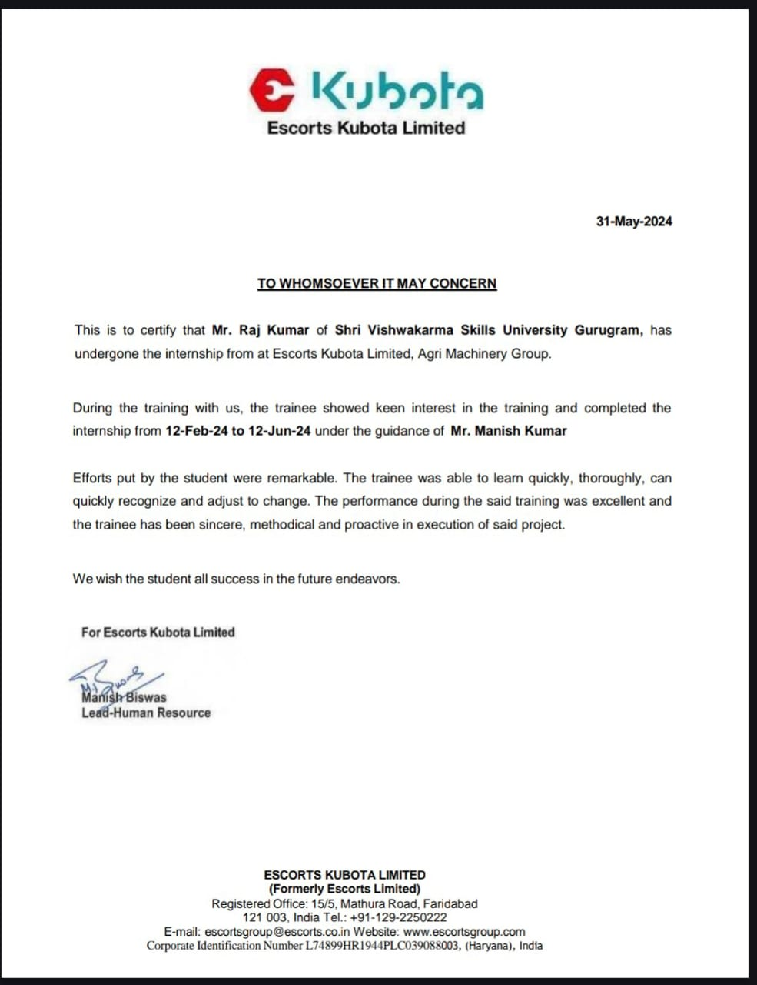**Certificate**

### CANDIDATE DECLARATION

I, Raj Kumar declare that the work presented in the dissertation entitled **“GRN Data Receipts Quantity Analysis”** submitted in the Skill Department of Management and Studies, Shri Vishwakarma Skill University Gurugram for the award of degree of Master of Business Administration is original and is an authentic record of my work that has been carried out by me during the year **2024** at SVSU, Gurugram under the supervision of **Dr. Dalip Raina** Skill Department of Management SVSU Gurugram.

The matter embodied in the work has not been submitted elsewhere by anyone for award of any other diploma or degree of this or any other University. The work taken from other paper and thesis is properly referenced, where used in this dissertation.

**Date:**

**Raj Kumar**

**Roll No.: 22L9MBA34106**

### CERTIFICATE

I**, Raj Kumar** hereby certify that the work which is being presented in the project report entitled **“GRN Data Receipts Quantity Analysis”** for the award of the degree in **Master of Business administration** submitted in the Skill Department of Management, Shri Vishwakarma Skill University Gurugram (Haryana) is original and is an authentic record of my work that has been carried out by me during a period from 12-02-2024 to 12-06-2024 under the supervision of Dr. Dalip Raina of. Shri Vishwakarma Skill University Gurugram (Haryana).

The matter presented in this project report has not been submitted by me for the award of any other degree or diploma in any other university/institute.

**ACKNOWLEDGEMENT**

I would like to express my deepest gratitude to the following individuals and organizations for their invaluable support and guidance throughout my internship at Escorts Kubota Company.

1. Dr. Dalip Raina I am thankful for the mentorship and continuous support provided during the project. Your insights and expertise have been instrumental in my professional development.

2. Escorts Kubota Company: I am grateful to the entire team at Escorts Kubota Companyon for the opportunity to work on this project and gain practical experience in the field.

Their support, encouragement, and assistance have been instrumental in the successful complete on of this project.

Raj Kumar

22L9MBA34106

### LETTER OF UNDERTAKING

I, **Raj Kumar** student of MBA( Business Analytics) , Roll No. **22L9MBA34106** hereby confirmed that the work presented in this Project submitted in the Skill Department of Management, SVSU for the award of degree of Master of Business Administration is original. I did not copy my report content either partially and completely from any other student report or any other paid and unpaid internet source. I have solely responsible the content of report. I did not provide plagiarized materials in my dissertation report. If, I am involved of plagiarism activities at any stage. Then University is authorized is an authentic record of my work that has been carried out by me during the year 2022-2024. at SVSU under the supervision of **Dr.** department of Management, SVSU.

The matter embodied in the work has not been submitted elsewhere by anyone for award of any other diploma or degree of this or any other University. The work taken from other paper and thesis is properly referenced, where used in this dissertation.

#### Date:

(Raj Kumar)

**Roll No.: 22L9MBA34106**

**CONTENTS**

## ESCORTS KUBOTA LIMITED

Escorts Kubota Limited is a joint venture between Escorts Limited, an Indian engineering company, and Kubota Corporation, a Japanese multinational company specializing in agricultural machinery, construction equipment, and railway equipment’s. Kubota established Kubota agriculture machinery India and entered the Indian market in 2008.

Escorts Limited is one of India’s leading engineering combinations operating in the high growth sectors of Agri-machinery, construction & material handling equipment, railway equipment and auto components. With over 1 million tractors in the fields in India, 16,500 construction and material handling equipment and 6 million auto-components manufactured till date, Escorts is leveraging its engineering expertise and positioning as a change agent in the agriculture, construction equipment and automotive sectors.

In 2017 escorts launched India’s first electric tractor concept, FARMTRAC 26E, as part of the new Escorts tractor series at Agrotechnical, Germany

In 2022-2023 Escorts limited and Kubota corporation reinforce their long-standing partnership and escorts limited became Escorts Kubota limited. Launched India’s first hybrid pick-n-carry cranes and mono chassis safe crane.

In 2021 -developed a state-of-the-art facility for developing axle mounted disc brake system.

Upgraded to silver level in IRIS certification for railway equipment business division. Escorts becomes the first company in India to receive Budni certification for its electric tractors. Kubota tractor production commencement.



**Plant policy**

* No.1 quality of the world
* Employee happiness
* Customer smiles

# Introduction:-

Goods Receipt Notes (GRNs) are critical documents in the procurement and supply chain management process. Here's some information about GRN data.

GRN data typically includes: Columns:-

S no., item vendor code, V. Name, GSTIN no, TRN type, Org, MRN no, MRN Date, Destination type code,

Item code, Revision, Description, Quantity Receive UOM Landed Rate ……..

**Date:** The date the goods were received.

**Supplier Information:** Details about the supplier, such as name, Supplier code, address, and contact information.

**Goods Details:** Description of the received items, Item code, including part numbers, descriptions, and specifications.

**Quantity Received:** The quantity of each item received.

**The procurement process** refers to the series of steps involved in acquiring goods or services from external sources. It typically involves identifying needs, selecting suppliers, negotiating terms, and managing contracts. Here's a simplified overview of the procurement process:

Identifying Needs: This involves determining what goods or services are required, as well as the quantity, quality, and specifications.

Supplier Selection: Potential suppliers are identified and evaluated based on factors such as cost, quality, reliability, and past performance. Requests for proposals (RFPs) or requests for quotations (RFQs) may be issued to solicit bids from suppliers.

Negotiation: Once suitable suppliers are identified, negotiations take place to agree on terms and conditions, including price, delivery schedules, payment terms, and warranties.

Contracting: A formal contract is drawn up outlining the agreed-upon terms and signed by both parties. The contract specifies the rights and obligations of each party and serves as a legal document.

Ordering: Purchase orders are issued to the chosen supplier, detailing the specific goods or services to be delivered, quantities, prices, and delivery dates.

Receipt and Inspection: Upon delivery, the goods or services are inspected to ensure they meet the specified requirements and quality standards.

Payment: Invoices are received from the supplier, verified against the purchase order and contract terms, and processed for payment according to agreed-upon terms.

Supplier Performance Evaluation: Periodic evaluations are conducted to assess supplier performance, including factors such as quality, timeliness, responsiveness, and adherence to contract terms.

Contract Management: Throughout the contract term, ongoing management is necessary to monitor performance, address issues or disputes, and ensure compliance with contract terms. Supplier Relationship Management: Building and maintaining positive relationships with suppliers is crucial for long-term success. This involves effective communication, collaboration, and problem-solving to optimize value and mitigate risks.

Analyzing Goods Receipt Note (GRN) data is **important for several reasons:**

Accuracy Check: GRN data helps ensure that the quantity and quality of goods received match what was ordered. Analyzing GRN data allows businesses to identify discrepancies or errors in deliveries, such as shortages, damages, or incorrect items.

Inventory Management: GRN data provides insights into the inflow of goods into inventory. By analyzing GRNs, businesses can track stock levels, monitor inventory turnover, and optimize inventory management processes to prevent overstocking or stockouts.

Supplier Performance Evaluation: GRN data helps assess the performance of suppliers in terms of delivery timeliness, accuracy, and quality. Analyzing GRNs allows businesses to identify reliable suppliers and address issues with underperforming ones.

Financial Control: GRN data is essential for financial control and accountability. Analyzing GRNs ensures that payments to suppliers accurately reflect the goods received and helps prevent overpayment or incorrect billing.

Quality Control: GRN data enables businesses to track the quality of received goods and identify trends or patterns in product quality. Analyzing GRNs helps identify potential issues with suppliers or products early, allowing for timely corrective actions.

Compliance Monitoring: GRN data can be used to ensure compliance with regulatory requirements and internal policies. By analyzing GRNs, businesses can verify that received goods meet regulatory standards, certifications, or specific contractual obligations.

Cost Control: Analyzing GRN data allows businesses to track costs associated with procurement, including purchase prices, shipping fees, and any additional charges. This helps identify opportunities to negotiate better terms with suppliers and optimize procurement spending.

Forecasting and Planning: GRN data provides valuable information for demand forecasting and planning. By analyzing historical GRNs, businesses can identify trends, predict future demand, and adjust procurement strategies accordingly to avoid stock shortages or excess inventory.

Risk Management: Analyzing GRN data helps businesses identify and mitigate various risks in the supply chain, such as supplier reliability, delivery delays, quality issues, or geopolitical factors. It enables proactive risk management strategies to minimize disruptions and ensure continuity of operations.

Performance Improvement: Continuous analysis of GRN data allows businesses to identify areas for improvement in the procurement process. By tracking key performance indicators (KPIs) related to GRNs, such as on-time delivery rates or accuracy of orders, organizations can implement measures to enhance efficiency and effectiveness.

Supplier Relationship Enhancement: GRN data analysis can support efforts to strengthen relationships with suppliers. By sharing insights from GRN analysis with suppliers, businesses can collaboratively address challenges, improve communication, and foster long-term partnerships based on trust and mutual benefit.

**The scope** of Goods Receipts Notes (GRN) data can encompass various aspects related to the receipt of goods within a business or organizational context. Here are some key elements that might be included in the scope of GRN data:

Receipt Details: Capturing detailed information about received goods, including the date of receipt, quantity received, description of the items, unit prices, total cost, supplier information, and any relevant purchase order or invoice numbers.

Item Identification: Identifying each item received using unique identifiers such as product codes, barcodes, or serial numbers to ensure accurate tracking and inventory management. Quality Control: Recording any quality control checks or inspections performed on the received goods to ensure they meet specified standards or requirements.

Storage Location: Documenting the location where the received goods are stored within the organization, such as warehouse shelves, bins, or racks, to facilitate efficient retrieval and inventory management.

Personnel: Logging information about the personnel responsible for receiving and inspecting the goods, including their names, roles, and any relevant signatures or approvals.

Delivery Information: Recording details about the delivery of goods, including the carrier or shipping company used, transportation mode, delivery date and time, and any associated tracking numbers or delivery documents.

Documentation: Storing copies of relevant documents such as delivery receipts, packing slips, bills of lading, and customs documentation to support the GRN records and facilitate auditing and compliance.

Integration: Integrating GRN data with other business systems such as inventory management, accounting, and procurement systems to ensure consistency and accuracy of data across different functional areas.

Reporting and Analysis: Generating reports and performing analysis on GRN data to gain insights into trends, supplier performance, inventory levels, receipt accuracy, and other key metrics to support decision-making and process improvement efforts.

Compliance and Auditing: Ensuring compliance with regulatory requirements and internal policies governing the receipt and documentation of goods, as well as facilitating auditing processes by maintaining accurate and complete GRN records.

The scope of GRN data may vary depending on the specific needs and requirements of the organization, industry regulations, and the complexity of the supply chain and procurement processes involved. However, capturing and managing detailed and accurate GRN data is essential for effective inventory management, financial control, and operational efficiency within businesses and organizations.

The **significance of Goods Receipts Notes (GRN)** data lies in its crucial role within the supply chain and inventory management processes of businesses and organizations. Here are some key highlights of its significance:

Inventory Management: GRN data serves as a vital component of inventory management systems, providing detailed records of goods received into the organization. By accurately tracking incoming inventory, businesses can maintain optimal stock levels, prevent stockouts or overstock situations, and ensure efficient utilization of resources.

Financial Control: GRN data forms the basis for financial control and accountability within organizations. It facilitates accurate recording of received goods, enabling proper reconciliation with purchase orders and invoices. This ensures that the organization's financial records reflect the actual goods received and the corresponding financial transactions.

Supplier Performance Evaluation: GRN data enables businesses to evaluate the performance of their suppliers based on factors such as delivery accuracy, timeliness, and product quality. By analyzing GRN data, organizations can identify reliable suppliers, address any issues with underperformance, and negotiate more favorable terms for future transactions.

Quality Assurance: GRN data includes information about quality control checks and inspections performed on received goods. This allows organizations to ensure that incoming inventory meets specified quality standards and requirements. Prompt identification of any quality issues enables timely corrective actions to be taken, preventing potential disruptions to operations or customer dissatisfaction.

Traceability and Compliance: GRN data provides a detailed audit trail of goods received, including documentation of delivery details, personnel involved, and associated paperwork. This facilitates traceability throughout the supply chain, supporting compliance with regulatory requirements, industry standards, and internal policies governing the receipt and documentation of goods.

Operational Efficiency: By streamlining the receipt and processing of goods, GRN data contributes to improved operational efficiency within organizations. It enables faster and more accurate handling of incoming inventory, reduces errors and discrepancies, and minimizes administrative overhead associated with manual data entry and reconciliation tasks.

Decision Making: Analyzing GRN data provides valuable insights into trends, patterns, and performance metrics related to inventory management and supply chain operations. This

information empowers decision-makers to make informed strategic and operational decisions, such as optimizing procurement processes, identifying cost-saving opportunities, and improving overall supply chain performance.

Customer Satisfaction: Accurate and timely receipt of goods is essential for meeting customer demand and ensuring high levels of customer satisfaction. GRN data enables organizations to fulfill orders promptly, prevent stockouts or delays, and maintain reliable supply chains, ultimately enhancing the customer experience and loyalty.

In summary, Goods Receipts Notes (GRN) data plays a crucial role in facilitating efficient and effective supply chain and inventory management processes, supporting financial control, supplier relationships, quality assurance, compliance, operational efficiency, decision-making, and customer satisfaction within businesses and organizations.

# Literature review

#### Research Question

* What is the Share of Business of each supplier of an item in percentage?
* Which suppliers have the highest and lowest rates of discrepancies in quantities received versus quantities ordered?
* What is the average cost per unit received, and how does this vary by supplier?
* What’s get either gain or loss over purchasing an item from multiple vendor.
* What’s we get either gain or loss over purchasing total quantity per vendor.

The primary objective of this analysis is to assess and improve inventory management, supplier performance, and overall supply chain efficiency through detailed examination of GRN data receipts.

#### Key Metrics

**Receipt Accuracy**: Discrepancy rates between ordered and received quantities.

**Timeliness:** Lead times from order placement to receipt.

**Inventory Turnover:** Rate at which inventory is replenished.

**Cost Efficiency:** Cost per unit received, handling, and processing costs.

**Supplier Performance:** On-time delivery rates, defect rates, and fulfillment rates.

Data Segmentation

**By Supplier:** Analysing data for individual suppliers to assess performance.

**By Product Category:** Segmenting data by product type to identify category-specific insights.

**By Location:** Considering geographical factors affecting lead time and receipt accuracy.

**By Time Period:** Comparing data across different months, quarters, and years.

Key Deliverables

**Comprehensive Report:** Detailed findings, including tables, charts, and graphs.

**Executive Summary:** Key insights and recommendations for management.

**Dashboard:** Interactive visualization of key metrics for real-time monitoring.

**Recommendations:** Actionable strategies for improving inventory management and supplier

Stakeholders

**Internal Stakeholders**: Supply chain managers, inventory controllers, procurement team, and senior management.

**External Stakeholders:** Key suppliers and logistics providers (if data sharing agreements are in place).

Limitations

Data Quality: Ensuring the accuracy and completeness of GRN data.

External Factors: Accounting for external factors such as market conditions and supplier-specific issues that may affect the data.

Scope Creep: Staying focused on the defined metrics and objectives to avoid expanding the scope beyond manageable limits.

Assumptions

Consistency in Data Recording: Assuming uniformity in how GRNs are recorded across the time frame.

Data Accessibility: Availability and accessibility of all necessary data from internal systems and stakeholders.

Execution Plan

Data Collection: Gather and clean GRN data from all relevant sources. Data Analysis: Apply the defined analytical methods to derive insights.

Validation: Verify the findings with relevant stakeholders to ensure accuracy. Reporting: Compile the results into the specified deliverables.

Review and Feedback: Present findings to stakeholders and incorporate feedback for final recommendations.

Author

Siti Ratna Sari Dewi

Faculty of Economics and Business Pamulang University. Banten. Indonesia

Jl. Surya Kencana No.1, Pamulang Bar., Kec. Pamulang, Kota Tangerang Selatan, Banten 15417 Email: [dosen01077@unpam.ac.id](mailto:dosen01077@unpam.ac.id)

#### Title

Analysis of Revenue Receipt and Methods for Recording Service Income

#### Summery

This research uses a combined method of observation and interviews to analyze income receipts and methods for recording service income at PT. Auto Jaya Tekno during the 2016-2018 period. Observations were carried out directly on the research object by participating in interactions in the PT's natural environment. Auto Jaya Tekno. Interviews were conducted with op-erational division area managers related to the research to obtain in-depth in-formation regarding the revenue receipt process and methods for recording service revenue. Data collection instruments involve interview and observa-tion guidelines, as well as special formats in tables and forms.

Data analysis uses descriptive techniques, utilizing the results of inter- views and observations. Data is constructed to provide an in-depth under-standing of the problem being studied; then, the results are compared with relevant theories. The research results show that PT. Auto Jaya Tekno has successfully implemented the SOP for recording income and costs with con-sistency using the accrual basis method in accordance with PSAK No. 23. Using the Limax system provides the advantage of automatic and simulta-neous recording of transactions. The company also continues to implement a credit sales policy by paying attention to the risk of bad debts. Thus, this re-search provides an in-depth overview of revenue receipts and methods of recording service revenue at PT—Auto Jaya Tekno, which can be a founda-tion for companies for efficient and accountable financial managemen

CONCLUSION

PT. Auto Jaya Tekno has succeeded in implementing well-structured SOPs for recording income and costs. Despite experiencing fluctuations in income, the company is consistent in adopting the accrual basis principle in accordance with PSAK No. 23. Thus, the systematicity and consistency of PT's income recording. Auto Jaya Tekno provides a strong foundation for efficient and accountable financial management. The use of the Limax sys-tem, which applies the accrual basis method, provides the advantage of re-cording income automatically and at the same time as transactions. In addi-tion, the company continues to implement a credit sales policy to increase sales volume, although it must pay attention to the risk of bad debts.

Income recognition method at PT. Auto Jaya Tekno adopts an accrual basis, where income

is recorded when a transaction occurs, even though payment has yet to be received in full. The recognition process consists of three stages: Own Risk payment, completion of service work by issuing an invoice, and payment by insurance. The entire revenue recording process is integrated into the Limax system, which ensures automatic and consistent recording

Author

. Assoc. Prof. Dr. R. Čiarnienė, Kaunas University of Technology 2. Prof. Dr. R. Dapkus, Vytautas Magnus University 3. Assoc. Prof. Dr. V. Tamulienė, Vytautas Magnus University 4.

A. Šumskis, UAB “Hegelmann Logistics” (Social partner)

#### Summary

Key words: logistics activity, logistics system, optimization, efficiency, supply chain management, management. Research object: improvement of supply chain management. Research aim: to suggest recommendations to improve supply chain management based on the case of "Walmart USA". Objectives: 1. To carry out a situation analysis of supply chain

structure; 2. To analyze theoretical foundation of supply chain management improvement; 3. To investigate the supply chain management of “Walmart USA”; 4. To justify the proposed solutions for analyzed company to improve supply chain management. Research methods. The following methods were used in solving the formulated tasks: analysis and synthesis of scientific literature, qualitative research methods - analysis of financial documents, value chain model, SCOR, semi-structured interview, graphic presentation of information. Research results: based on the results of the company's activities and conversations with its representatives, 6 main strategies and recommendations for the development of the future supply chain were derived; a broader future projection of Walmart's supply chain was defined. The first part of the work revealed the importance of supply chain management and its improvement. The second part of the paper examines the concept of supply chain management, its structural elements and activities, supply chain models and their role in chain management, factors influencing management are identified, potential risks are identified, opportunities for improvement of supply chain management are revealed, and an empirical research methodology is presented. 5 In the third part of the work, Walmart USA is presented, based on the research methodology, the financial statements of Walmart USA for 2020-2022 were evaluated. economic activity and industry analysis, analysis based on Porter's five forces model, formation of Walmart USA SCOR model, suggestions for improving supply chain management at Walmart USA.

**CONCLUSIONS**

There was carry out a situation analysis of supply chain structure. The effectiveness of the functioning of logical systems, as well as the problems of optimizing the logistics activities of the enterprise, which is related to the logistical structure in the enterprise, are of significant importance. Effective control in logistics relations took into account that the activity of enterprises was noted in general. Logistics is becoming an effective tool for increasing the productivity of companies, therefore many enterprises seek to optimize the management of their supply chains and create added value in the process of moving goods to final customers.

In the work was analyzed theoretical foundation of supply chain management improvement. Supply chain management can improve financial performance; lead to satisfied customers; reduce delivery times; and build trust, confidence and commitment among suppliers. However, integrating supply chains to achieve expected benefits is a key strategic challenge since managers operate in a complex, turbulent and highly competitive environment in which quick response to customer needs and flexibility are vital for firm survival and success. Therefore, even if every firm would like to integrate its supply chain with others, the decision to integrate supply chain and achieve the resulting benefits is influenced several factors. These factors include: management attitude to risk; the firm’s size, resources and targeted market; the firm’s geographical location, the firm’s customers, suppliers and competitors; and the firm’s structure. There was main foundings related to objectives of work:

1. It was carried out a situation analysis of supply chain structure. There was identified that experts and researchers in the field of logistics highlight the interrelationships and relationships of logistics and supply chain management. This is caused, in part, by the fact that supply chain management and logistics are frequently seen from different perspectives when conducted overseas. Conversely, experts with a wealth of experience but a distinct set of knowledge arrived in this sector of the market. This has both positive and negative effects. On the one hand, it enriches logistics and supply chain management by fusing different disciplines and creating interdisciplinary sciences. On the other hand, people frequently tend to minimize logistics and supply chain management problems to the level of knowledge they possess.
2. Analyzed theoretical foundation of supply chain management improvement. Overall, the emphasis in the interpretation of the term is moving more and more toward the broader definition of supply chain management (SCM) found in the compilation that supply chain management is the coordination, planning, control, and implementation of the flow of products from the point of design and procurement through production and distribution to the end user in compliance with cost-effectiveness standards set by the market.
3. Investigated the supply chain management of “Walmart USA”. There was investigate the supply chain management of “Walmart USA”. The main areas of activity of the "Walmart USA" enterprise were indicated, an economic analysis of financial stability was carried out, as well as an industry analysis, SCOR model, financial analysis, value chain model analysis of the enterprise and a SWOT analysis. For additional determination, an interview was conducted with the TOP representatives of the company. Indicators have an economic and financial characteristic, an estimated current state and growth prospects. In general, the company works in a harmonious environment and is gradually developing on the international market, that is, scaling up its activity. At the same time, the financial condition of the enterprise can be very important. “Walmart USA” is engaged in the sale of its products through intermediaries who participate in all quiet business dealing with retail trade, use multi-channel distribution.
4. Justified the proposed solutions for analyzed company to improve supply chain management. Based on the results of the company's activities and interviews with its representatives, 6 main strategies and recommendations for the development of the future supply chain were derived, namely:

* Improvement of the distribution network;
* Cash flow monitoring for supply chain risk management;
* Designing a map of sustainable development of the supply chain;
* Advanced technologies and data analytics.
* Strategic partnership and cooperation;
* Increasing stability.

In the work were defined Walmart's supply chain broader projection for the future, which is defined below, such as:

1. Fulfillment centers will become a new kind of store;
2. The future supply chain will include a network model;
3. Effective technology will be adopted in the future supply chain;
4. Digital transformation is considered the biggest future.

Author

Qingfei Tong, Xinguo Ming and Xianyu Zhang * Institute of Industrial Engineering and Management, School of Mechanical Engineering, Shanghai Jiao Tong University, 800 Dongchuan Road, Minhang District, Shanghai 200240, China * Correspondence: [leitun@sjtu.edu.cn](mailto:leitun@sjtu.edu.cn)

#### Summary

The integration and application of a warehouse system and manufacturing system has become a manufacturing problem for enterprises. The main reason is that the information control system based on automation and stereo warehouse is inconsistent with the production and management information system of the enterprise in terms of business, data, functions, etc. Based on this, this paper studies the implementation of an automated warehouse based on the integration of ERP (enterprise resource planning) and WMS (warehouse management system) with the method and technology of the intermediate table. Moreover, MES (manufacturing execution system) is the brain and the core part of a sustainable digital factory. The enterprise adopts advanced intelligent and information technology to build and deploy the MES, realize fine management and agile production, and meet the personalized needs of the market. Therefore, this paper studies the implementation path and effect based on MES from an industrial realization to construct a sustainable digital factory. The research results of this paper can improve industrial efficiency and reduce costs for enterprises in storage capacity, handling capacity, response rate, rate of error, number of operators, etc.

**Conclusions**

In this paper, an overall architecture of a sustainable digital factory is proposed, and the integration of ERP and WMS for an automated warehouse is studied. Then, an industrial

realization and an implementation effect are studied. At last, a case study is given. The research on the construction of a sustainable digital factory is focused on the concept and value of a sustainable digital factory, as well as the main contents and precautions of sustainable digital factory construction. However, there is still a lack of research on how to build a sustainable digital factory based on MES, especially from the aspects of framework construction, implementation path, index evaluation, etc. This paper combines the method and technology of the middle table, and the realization of an automated warehouse based on the integration of ERP and WMS is studied to solve these above problems. A sustainable digital factory is the main way to realize intelligent manufacturing. MES is the brain and the core part of a sustainable digital factory. The enterprise adopts advanced intelligent and information technology to build and deploy the MES system platform, realize fine management and agile production, and meet the personalized needs of the market. The main contributions of this study are as follows: (1) an overall architecture of a sustainable digital factory is constructed from the perspective of top- level design. (2) The method and technology of middle table is pro-posed for the integration of ERP and WMS for automated warehouse. (3) The industrial realization, implementation effect, and apFigure 9. On-site physical objects based on integration and docking of ERP and WMS. It can be seen that through the integration and docking of ERP and WMS, the industrial effects on storage capacity, handling capacity, response rate, rate of error, and number of operators for enterprises are very significant. 7. Conclusions In this paper, an overall architecture of a sustainable digital factory is proposed, and the integration of ERP and WMS for an automated warehouse is studied. Then, an industrial realization and an implementation effect are studied.

**OBJECTIVES**

* To see what we get either gain or loss over purchasing an item from multiple vendor.
* To see what we get either gain or loss over purchasing total quantity per vendor.



**MATHODOLOGY**

**Literature review:** Conduct a comprehensive review of existing literature on Goods Receipts notes data Analysis

**Data collection:** I used secondary data of Escorts Kubota Company which is provided by my mentor

**Data Analysis Techniques**: **Used ETL** (Extract Transforming & Loading) Process

**Extract** (means take data from Production Planning & Controlling Department through mail called GRN data, and through Oracle Database called SOB data)

**Transforming** (means cleaning data to convert into meaningful data)

**Loading (**Once the data has been transformed, it is loaded into the target database)

**Weighted average** (A weighted average is a type of average where different data points are given different weights based on their importance or relevance. It is calculated by multiplying each data point by its corresponding weight, summing up these products, and then dividing by the sum of the weights.)

For calculating wt. avg. first we open GRN data in an Excel.

#### Wt. avg. for single item code

* Add a column where use product function of quantity receive and landed rate
* Again add a column name wt. avg. use function

=SUMIF($B$2:$B$34,B2,$V$2:$V$34)/SUMIF($B$2:$B$34,B2,$P$2:$P$34)

* Here b2 to b34 is item vendor code
* V2 to v34 is product of qt and landed rate
* P2 to P34 is qt. receive.

Here more than one vendor for a single item, so we use **sumif function** in case one supplier of a item then we use only **sum function.**

#### How to calculate wt. avg. per vendor

* total qt. all vendor of a item==SUMIF($H$6:$H$70326,H6,$J$6:$J$70326)
* total qt. per vendor=SUMIF($B$6:$B$70326,B6,$J$6:$J$70326)
* a vendor contribution in single item in %age==O6/N6
* qt. from single vendor==J6/O6
* prices per item from single vendor=Q6*L6
* wt. avg. per vendor==SUMIF($B$6:$B$70326,B6,$R$6:$R$70326)

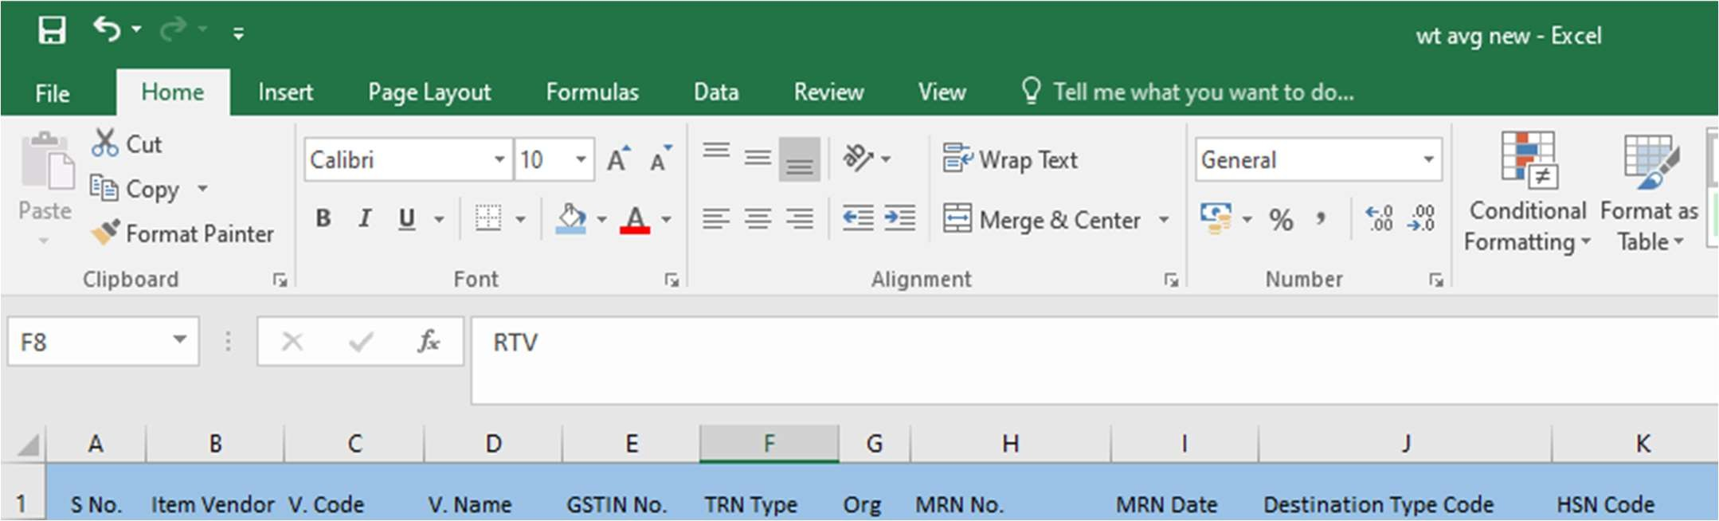

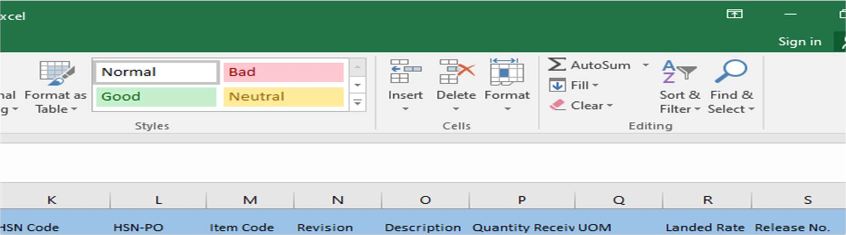

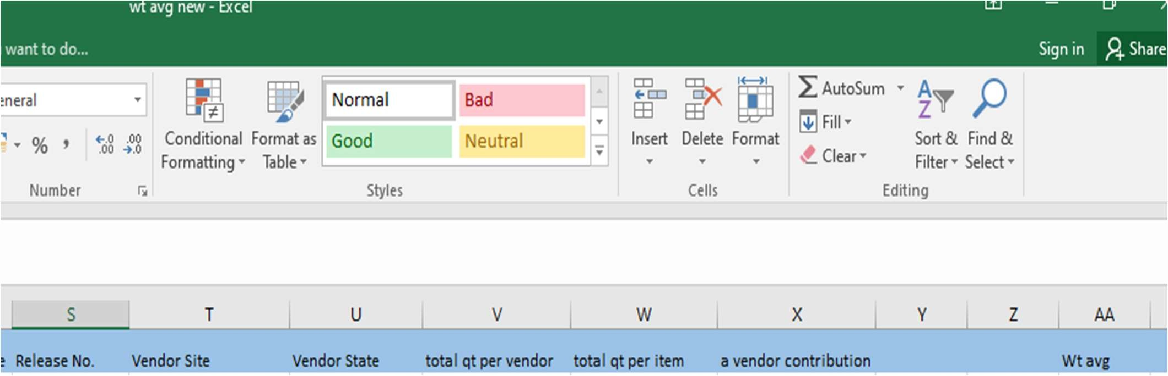

**Wt. avg. for whole sheet**



First we calculate total qt per item



We calculate total qt per vendor



Calculate vendor contribution in parsantage



Calculate per vendor qt Received



Calculate rate



Then final calculate wt. avg.

After calculating Wt. avg. I was given **System SOB (Share of business) data**, this data was in a form of raw format. Means in data many case have share of business of all vendors of a item code have more than and less than to 100%. For correct this error needed to convert share of business of all vendors of an item code into 100%. To convert SOB into 100% I performed several activities which are given blow:-



First added a column



Then useed sumif Function For Sum of SOB



Filtered where sum of SOB of a item greater than 100%



Then deleted a row by which this error occurred



And repeated this step to all item



Final our data is converted into meaningful data

* After both sheet data is competed then GRN data putted on SOB data after this both GRN and SOB data have Share of business 0f all vendor of an item was less than to 100%. In GRN data This error have around 16 rows, Here I deleted these rows but in case of SOB data where 586 something rows have this error to converted into 100% I fetch the values From GRN data first makes Pivot table where Item vendor code and item code putted in row and total qt. from an item put in row.
  + From this pivot table fetch the values using Vlookup function based on item vendor code. And around 286 cases where single vendor have 0% share of business we considered 0% into 100%, and coloured these case. Because in these case price of System Sob data is not correct because we consider share of business 100% so I
  + considered it 0 if you need you can go through oracle DB.
* Now Calculate System value (Prices acc. to SOB date) using product function of wt. avg.

* qt. receive per vendor of SOB data

* Now calculate Actual value (Prices acc. to GRN data) using product function of wt. avg.

* qt. receive per vendor of GRN data

* Calculate difference b/w system value and Actual value
* Calculate gain loss over Purchasing item used if function (if Diff is greater than 0 we get gain, equal to 0 no gain no loss, if less than 0 we get loss)
* Only taking gain loss case, I make a Dashboard using Power BI.

**Dashboard for whole sheet**

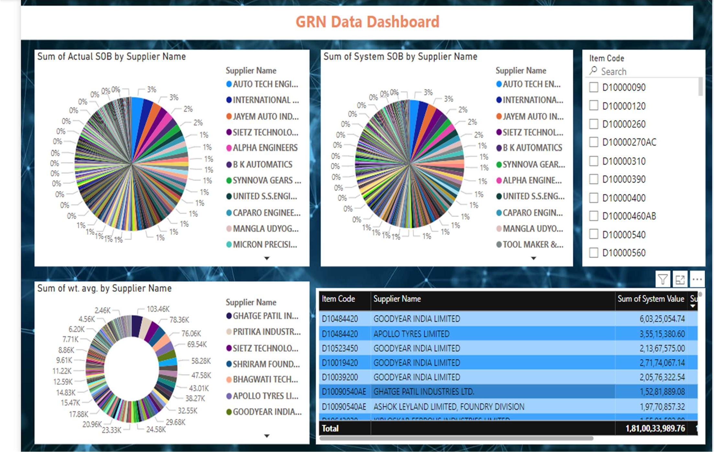

**Dashboard for an item**

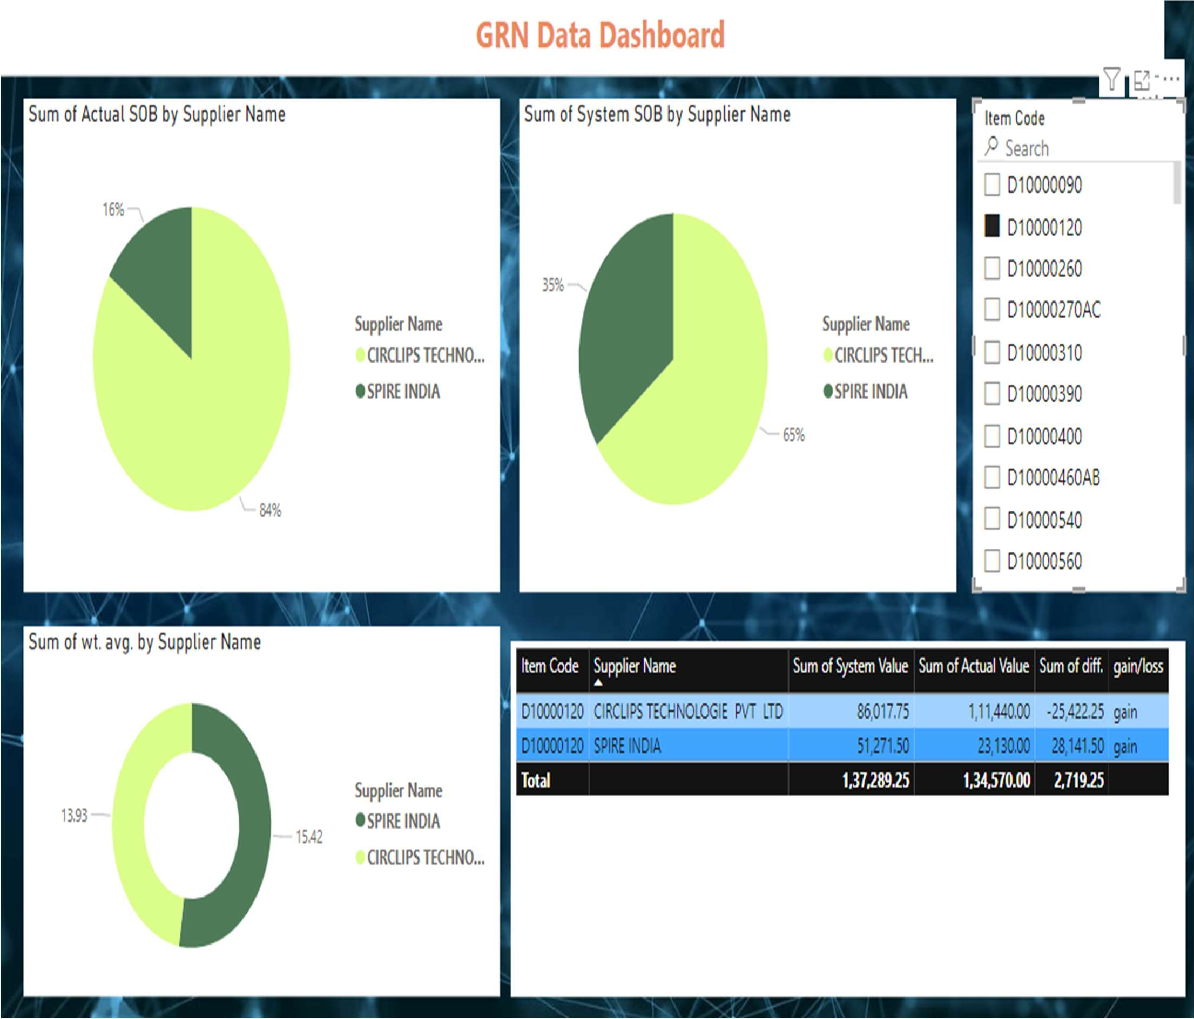

In this dashboard a single item code is filtered, this item have two supplier which are showed in dashboard and in both pie chart showed the SOB of both acc. to Actual and System data next chart show the wt. avg. of both supplier in next table which show that prices of both system and actual data, So by seeing this we can said that to purchase this item we get profit from both supplier.

Like this we see gain/loss by simply select what you want.

**Dashboard acc. to Supplier**

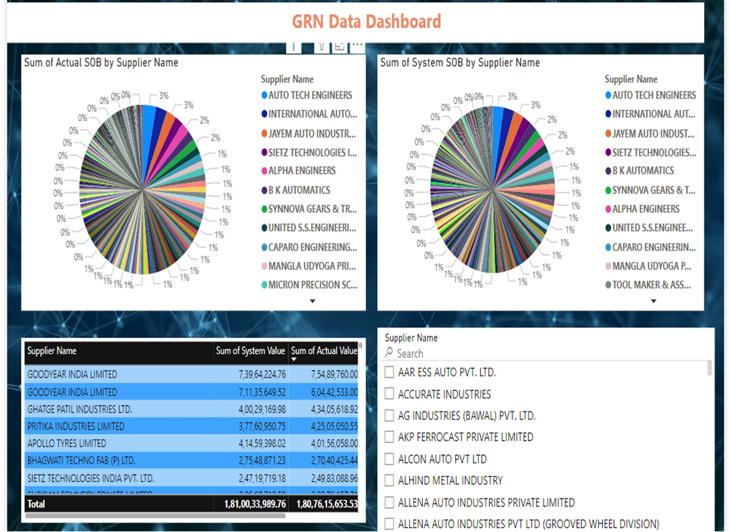

**Dashboard for a supplier**

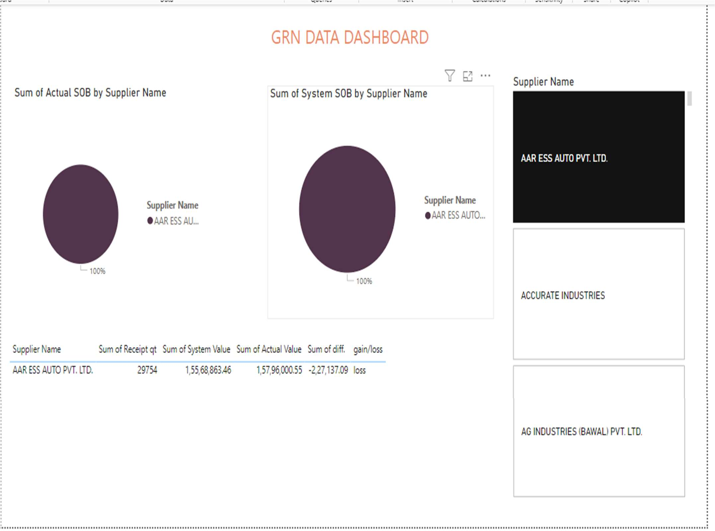

Here a single supplier is selected to see we get either gain or loss while purchasing total qt. from a supplier through this dashboard we can say that get loss purchasing 29754 unit qt.

Like this we see gain/loss by simply select what you want.

LIMITATION

When conducting a Goods Receipt Note (GRN) data receipt quantity analysis project, you may encounter several limitations that could affect the accuracy and usefulness of your analysis. Here are some common limitations to consider:

Data Quality Issues

Inaccurate Data: Errors in data entry can lead to inaccurate receipt quantities being recorded. Incomplete Data: Missing data points can skew analysis results, making it difficult to draw accurate conclusions.

Inconsistent Data: Variations in how data is recorded (e.g., different units of measure) can complicate analysis.

System Limitations

Integration Issues: Difficulty in integrating GRN data with other systems (e.g., inventory management, ERP systems) can limit comprehensive analysis.

Data Storage Limitations: Constraints on how much data can be stored and accessed may impact long-term analysis.

Human Factors

Manual Entry Errors: Manual data entry increases the risk of errors, which can distort the analysis.

Training and Knowledge: Lack of proper training for staff on how to correctly record GRN data can lead to inconsistencies and inaccuracies.

Timing and Frequency

Timing of Data Entry: Delays in entering GRN data can result in discrepancies between actual and recorded quantities.

Frequency of Data Updates: If data is not updated regularly, it can affect the timeliness and relevance of the analysis.

Data Interpretation Challenges

Complexity of Data: Analyzing large volumes of GRN data can be complex and time- consuming, requiring specialized skills and tools.

External Factors

Supplier Variability: Variability in supplier performance (e.g., partial deliveries, over-deliveries) can complicate analysis.

Analytical Limitations

Lack of Advanced Tools: Limited access to advanced analytical tools and software can restrict the depth of analysis.

Static Analysis: Static reports and analysis may not capture real-time changes and trends in GRN data.

Strategies to Mitigate Limitations

Data Validation: Implement robust data validation and verification processes to improve data quality.

Training Programs: Provide comprehensive training for staff on accurate data entry and the importance of maintaining data integrity.

Regular Audits: Conduct regular audits and reconciliations of GRN data to identify and correct discrepancies.

Advanced Tools: Invest in advanced data analytics tools and software to enhance the depth and accuracy of the analysis.

Integrated Systems: Ensure seamless integration between GRN and other business systems to provide a holistic view of inventory and supply chain operations.

Real-Time Data Processing: Utilize real-time data processing capabilities to ensure the analysis reflects the most current data.

## CONCLUSION

Acc. to dashboard for an item, a single item code is filtered, this item have two supplier which are showed in dashboard and in both pie chart showed the SOB of both acc. to Actual and System data next chart show the wt. avg. of both supplier in next table which show that prices of both system and actual data, So by seeing this we can said that to purchase this item we get profit from both supplier.

Acc. to dashboard for a supplier where a single supplier is selected to see we get either gain or loss while purchasing total qt. from a supplier through this dashboard we can say that we get loss purchasing 29754 unit qt. Like this we see gain/loss by simply select what you want.

## References

(google schoolar, n.d.)

Dewi, S. R. (2023, Dec 17). Retrieved from https://[www.ejournal.joninstitute.org/index.php/ProBisnis/article/view/385](http://www.ejournal.joninstitute.org/index.php/ProBisnis/article/view/385)

*google schoolar*. (n.d.). Retrieved from https://scholar.google.com/

Qingfei Tong, X. M. (2023, Jan 05). Retrieved from file:///C:/Users/C- Raj.Kumar/Downloads/sustainability-15-01022-v2.pdf

Dewi, S. R. (2023, Dec 17). Retrieved from https://[www.ejournal.joninstitute.org/index.php/ProBisnis/article/view/385](http://www.ejournal.joninstitute.org/index.php/ProBisnis/article/view/385)

(Qingfei Tong, 2023)

Dewi, S. R. (2023, Dec 17). Retrieved from https://[www.ejournal.joninstitute.org/index.php/ProBisnis/article/view/385](http://www.ejournal.joninstitute.org/index.php/ProBisnis/article/view/385)

Qingfei Tong, X. M. (2023, Jan 05). Retrieved from file:///C:/Users/C- Raj.Kumar/Downloads/sustainability-15-01022-v2.pdf